## Activity 1

**Aim:** Insert data into databases and Delete insert values.

# **Learning outcome**: Able to configure embedded databases with different web pages using XAMPP and MySQL.

###### Duration: 1 hour

# List of Hardware/Software requirements:

* Laptop/Computer with windows
* XAMPP software(apache)
* Composer
* Dll file
* Mongodb

# Insert values

Step -1 First we need to connect with mongoDB with the help of composer and php dll file.

Step -2 Create a new file into the

* htdocs

mongophp

connection.php

Input:

<?php

require 'vendor/autoload.php';

$con =new MongoDB\Client("mongodb://localhost:27017");

echo "Connection Successfully";

//How to create database and insert values inside of mongoDB.

$db=$con->nsti;

echo "<br>Database created successfully";

//create collection

$tb1=$db->subjects;

echo "<br>collection created successfully";

//insert value

$tb1->insertOne(["Language"=>"PHP"]);

$tb1->insertOne(["Database"=>"MongoDB"]);

$tb1->insertOne(["Framwork"=>"Laravel"]);

echo "<br> Data Inserted";

?>

Output:

Go to MongoDB Compass. There you can see a new database with collection.

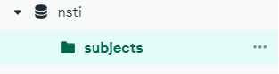

Also, you can see the insert values as follow.

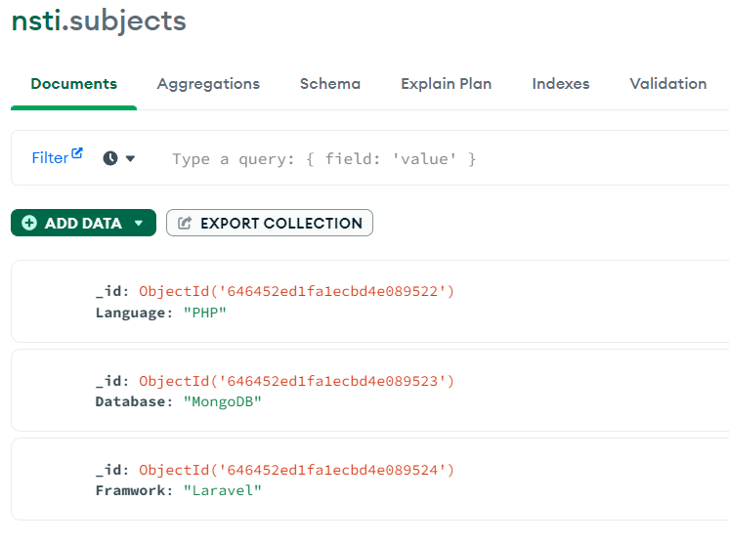

# Delete Insert values

Input:

<?php

require 'vendor/autoload.php';

$con =new MongoDB\Client("mongodb://localhost:27017");

echo "Connection Successfully";

//How to create database and insert values inside of mongoDB.

$db=$con->nsti;

echo "<br>Collection created successfully";

//create collection

$tb1=$db->subjects;

echo "<br>collection created successfully";

//insert value

$tb1->deleteOne(["Language"=>"PHP"]);

echo "<br> Data Deleted!";

?>

Output:

